**Camp Education Society’s**

**Dr. Arvind B Telang College of Art, Commerce & Science, Nigdi, Pune-44**



**A**

**Project Report**

**On**

**“ Blood Bank Management System ”**

**Developed by,**

**2912 : Dhananjay M. Bhagat**

**2908 : Bhagirath T. Koli**

**2926 : Prashant S. Jagtap**

**T.Y.Bsc.(Computer Science)**

Under



**Savitribai Phule Pune University**

**(2021-2022)**

**Camp Education Society’s**

**Arvind B Telang Sr College of Arts, Commerce & Science, Nigdi, Pune-44**

**Department of Bsc (Computer Science)**



**Certificate**

This is to certify that **Mr. Dhananjay Bhagat & Mr. Prashant Jagtap & Mr. Bhagirath Koli** has**/** have satisfactorily completed the **Project titled** **“Blood Bank Management System”** for **T.Y.Bsc(Computer Science) - Semester – VI Course Type : SECC-IV Course Code: CS Project under** the **Savitribai Phule Pune University in** the academic year **2021-2022.**

**____________________ ___________________ ____________________**

**Dr. Prakash Patil Mrs. Rewati Rane Prof. Yogesh Kadam**

**Principal Program Coordinator Project Guide**

**__________________ _________________**

**Internal Examiner External Examiner**

**Date:**

**ACKNOWLEDGEMENT**

Any effort to produce successful creation requires the help, guidance and support of many people and their experience. We would like to express our sincere and heartfelt gratitude to all of them.

We would like to take this opportunity to thanks all the people who have directly or indirectly helped this project. We would like to thank our guide Prof. **Yogesh Kadam**, for his valuable guidance.

**Mr. Prashant Jagtap.**

**Mr. Dhananjay Bhagat.**

**Mr. Bhagirath Koli.**

**INDEX**

|  |  |  |
| --- | --- | --- |
| **S. NO** | **CONTENTS** | PAGE NO. |
|  | Introduction | 1 |
|  | Need of Blood Bank Management System | 2 |
|  | Abstract of Blood Bank Management System | 4 |
| 4. | Benefits | 4 |
| 5. | Objective | 4 |
| 6. | About Front End | 5 |
| 7. | Software Tools Use | 5 |
| 8. | PHP | 6 |
| 9. | HTML | 7 |
| 10. | CSS | 8 |
| 11. | JAVASCRIPT | 8 |
| 12. | 4.2 Algorithms | 9 |
| 13. | Implementation | 11 |
| 14. | 5.1. Partial code  5.2 Screen shots | 11  19 |
| 15. | Conclusion and Future Enhancement | 23 |

* **INTRODUCTION:**

***Blood Bank Management System***

The BLOOD BANK MANAGEMENT SYSTEM is great project. this project is designed for successful completion of project on blood bank management system. the basic building aim is to provide blood donation service to the city recently. Blood Bank Management System (BBMS) is a browser based system that is designed to store, process, retrieve and analyze information concerned with the administrative and inventory management within a blood bank. This project aims at maintaining all the information pertaining to blood donors, different blood groups available in each blood bank and help them manage in a better way. Aim is to provide transparency in this field, make the process of obtaining blood from a blood bank hassle free and corruption free and make the system of blood bank management effective.

The *Blood bank system project report* contain information related to blood like

* Blood type
* Date of Donation of blood
* validity of Bloods
* Available Blood group

**1.2 Need of Blood Bank Management System**

Bank blood donation system in java is planned to collect blood from many donators in short from various sources and distribute that blood to needy people who require blood. To do all this we require high quality software to manage those jobs. The government spending lot of money to develop high quality “Blood Bank management system project”. For do all those kinds of need blood bank management system project in java contain modules which are include the detail of following areas:

* Blood Donor
* Equipments
* Stick
* Blood Recipient
* Blood collection
* Camp
* Stock details
* blood bank system project Reports
* Blood issued

**1.3 Abstract of Blood Bank Management System**

Help Line is an voluntary and non-governmental organization.It maintains Online library of blood donors in India. Sometimes Doctors and Blood bank project have to face the difficulty in finding the blood group Donors at right time. Help Line has attempted to provide the answer by taking upon itself the task of collecting Blood bank project nationwide for the cause and care of people in need.

At any point of time the people who are in need can reach the donors through our search facility. By mobilizing people and organization who desire to make a difference in the lives of people in need. On the basis of humanity, Everyone is welcome to register as a blood donor.

Blood Bank Management System (BBMS) is a browser based system that is designed to store, process, retrieve and analyze information concerned with the administrative and inventory management within a blood bank. This project aims at maintaining all the information pertaining to blood donors, different blood groups available in each blood bank and help them manage in a better way. Aim is to provide transparency in this field, make the process of obtaining blood from a blood bank hassle free and corruption free and make the system of blood bank management effective.

**1.4 Benefits**

**Our Vision**

In the IT era, there are almost not any fields exist where computers are not used. Techshot would like to contribute to the total SATISFACTION to its esteemed CUSTOMERS by providing them with the high quality products.

Techshot wants to make products highly reliable, affordable, & consistent which will serve the customer domain.

Techshot concerned for its customers & serves them in precise time, with right product of right quality. By enhancing consulting and other potentials, we help move customers forward in each & every part of their businesses, from strategic planning to day-to-day operations.

Our Clients benefit from access to information solutions that help them better cope-up their business, cooperate with customers and make financial and operational decisions.

**1.5 OBJECTIVE:**

The main objective of this application is to automate the complete operations of the blood bank. They need maintain hundreds of thousands of records. Also searching should be very faster so they can find required details instantly.

To develop a web-based portal to facilitate the co-ordination between supply and demand of blood . This system makes conveniently available good quality, safe blood and other blood components, which can be provided in a sound, ethical and acceptable manner, consistent with the long-term well being of the community. It actively encourage voluntary blood donation, motivate and maintain a well-indexed record of blood donors and educate the community on the benefits of blood donation. This will also serve as the site for interaction of best practices in reducing unnecessary utilization of blood and help the state work more efficiently towards self-sufficiency in blood.

The system will provide the user the option to look at the details of the existing Donor List, Blood Group and to add a new Donor. It also allows the user to modify the record. The administrator can alter all the system data.

**1.6. About Front End:**

The front end is an [interface](https://en.wikipedia.org/wiki/Interface_(computer_science)) between the user and the back end. The front and back ends may be distributed amongst one or more systems.

In [network computing](https://en.wikipedia.org/wiki/Computer_network), *front end* can refer to any hardware that optimizes or protects network traffic. It is called [application front-end hardware](https://en.wikipedia.org/wiki/Denial_of_service) because it is placed on the network's outward-facing front end or boundary. Network traffic passes through the front-end hardware before entering the network.

In [compilers](https://en.wikipedia.org/wiki/Compilers), the [front end](https://en.wikipedia.org/wiki/Compilers) translates a computer programming [source code](https://en.wikipedia.org/wiki/Source_code) into an [intermediate representation](https://en.wikipedia.org/wiki/Intermediate_representation), and the back end works with the intermediate representation to produce code in a computer output language. The back end usually optimizes to produce code that runs faster. The front-end/back-end distinction can separate the [parser](https://en.wikipedia.org/wiki/Parsing) section that deals with source code and the back end that [generates code and optimizes](https://en.wikipedia.org/wiki/Code_generation_(compiler)).

These days, front-end development refers to the part of the web users interact with. In the past, web development consisted of people who worked with Photoshop and those who could code HTML and CSS. Now, developers need a handle of programs like Photoshop and be able to code not only in HTML and CSS, but also JavaScript or jQuery, which is a compiled library of JavaScript.

Most of everything you see on any website is a mixture of HTML, CSS, and JavaScript, which are all controlled by the browser. For example, if you’re using Google Chrome or Firefox, the browser is what translates all of the code in a manner for you to see and with which to interact, such as fonts, colors, drop-down menus, sliders, forms, etc. In order for all of this to work, though, there has to be something to support the front-end; this is where the backend comes into play.

* **Literature Survey:**

We made a system through which admin can manage information about donors. So that whenever blood is needed they can use this information as blood bank authorized officers have access to this information.

This site links all donors and help in controlling blood transfusion process. It will also maintain database which hold data of donors and blood according to their city and further by their locality.

* **Software & Tools Used:**

**1. PHP:-**

**2.1.1 Introduction**

PHP is now officially known as “**PHP: Hypertext Preprocessor**”. It is a server-side scripting language usually written in an HTML context. Unlike an ordinary HTML page, a PHP script is not sent directly to a client by the server; instead, it is parsed by the PHP binary or module, which is server-side installed. HTML elements in the script are left alone, but PHP code is interpreted and executed. PHP code in a script can query databases, create images, read and write files, talk to remote servers – the possibilities is endless. The output from PHP code is combined with the HTML in the script and the result sent to the user’s web-browser, therefore it can never tell the user whether the web-server uses PHP or not, because the entire browser sees is HTML.

**Reasons for using PHP**

* **Learning PHP is easy**
* **Its Performance**
* **The low cost**
* **It’s Open Source, We can modify it**

**Basic PHP Syntax**

A PHP scripting block always starts with **<?php** and ends with **?>**. A PHP scripting block can be placed anywhere in the document. On servers with shorthand support enabled you can start a scripting block with <? And end with ?>. However, for maximum compatibility, we recommend that you use the standard form (<?php) rather than the shorthand form.

A PHP file normally contains HTML tags, just like an HTML file, and some PHP scripting code.

**2.2.2 HTML**

**HTML** or **Hyper Text Markup Language** is the standard markup language used to create web pages.

HTML was created in 1991 by Tim Berners-Lee at CERN in Switzerland. It was designed to allow scientists to display and share their research.

HTML is written in the form of HTML elements consisting of *tags* enclosed in angle brackets(like <html>). HTML tags most commonly come in pairs like <h1> and </h1>, although some tags represent *empty elements* and so are unpaired, for example <img>. The first tag in a pair is the *start tag*, and the second tag is the *end tag* (they are also called *opening tags* and *closing tags*).

**a) HTML Images - The <img> Tag and the src Attribute**

In HTML, images are defined with the <img> tag.

The <img> tag is empty, which means that it contains attributes only, and has no closing tag.

To display an image on a page, you need to use the src attribute. Src stands for "source". The value of the src attribute is the URL of the image you want to display.

**2.2.3 CSS**

**Cascading Style Sheets** (**CSS**) is a style sheet language used for describing the look and formatting of a document written in a markup language. While most often used to style web pages and user interfaces written in HTML and XHTML, the language can be applied to any kind of XML document, including plain XML, SVG and XUL. CSS is a cornerstone specification of the web and almost all web pages use CSS style sheets to describe their presentation.

**2.2.4 JAVASCRIPT**

**JavaScript** (**JS**) is a dynamic computer programming language. It is most commonly used as part of web browsers, whose implementations allow client-side scripts to interact with the user, control the browser, communicate asynchronously, and alter the document content that is displayed. It is also being used in server-side network programming (with Node.js), game development and the creation of desktop and mobile applications.

* **Softwares and tools used:**

**3. My Sql:**

**Introduction:**

The database has become an integral part of almost every human's life. Without it, many things we do would become very tedious, perhaps impossible tasks. Banks, universities, and libraries are three examples of organizations that depend heavily on some sort of database system. On the Internet, search engines, online shopping, and even the website naming convention would be impossible without the use of a database. A database that is implemented and interfaced on a computer is often termed a database server.

**Reasons to Use MySQL**

* **Scalability and Flexibility**
* **High Performance**
* **High Availability**
* **Robust Transactional Support**
* **Web and Data Warehouse Strengths**
* **Strong Data Protection**
* **Management Ease**
* **Minimum Hardware Specification:**

**4.1 Hardware Requirement**

Processor : Intel Core Duo 2.0 GHz or more

RAM : 1 GB or More

Harddisk : 80GB or more

Monitor : 15” CRT, or LCD monitor

Keyboard : Normal or Multimedia

Mouse : Compatible mouse

**4.2 Software Requirement**

Front End : Visual Basic 2008 Express edition

With Sql Server Compact Edition

Microsoft SDK 3.0

Back End : MS Sql Server

Operation System : Windows 7 with server pack 2

OS

Windows 8.1

**5. Systems Development Phases**

Systems Development Life Cycle (SDLC) adheres to important phases that are essential for developers, such as planning, analysis, design, and implementation, and are explained in the section below. There are several Systems Development Life Cycle Models in existence. The oldest model, that was originally regarded as "the Systems Development Life Cycle" is the waterfall model: a sequence of stages in which the output of each stage becomes the input for the next.

* **Initiation**
* **System Concept Development**
* **Planning Requirement Analysis**
* **Design**
* **Development**
* **Integration Test**
* **Implementation**
* **Operation & Maintenance**
* **Module Description**

**BLOOD DONATION**  is a website based on PHP. The purpose of this project was to develop a blood management information system to assist in the management of blood donor records and ease or control the distribution of blood in various part of country basing on the hospitals demand. . This project includes mainly two modules i.e. login and main page.

* **Login**

The page require user name and password to start the application. Login is a process by which individual access to a computer system is controlled by identifying and authenticating the user through the cardinalities presented by the user. Admin can add update or delete the user, city, state, camp etc.

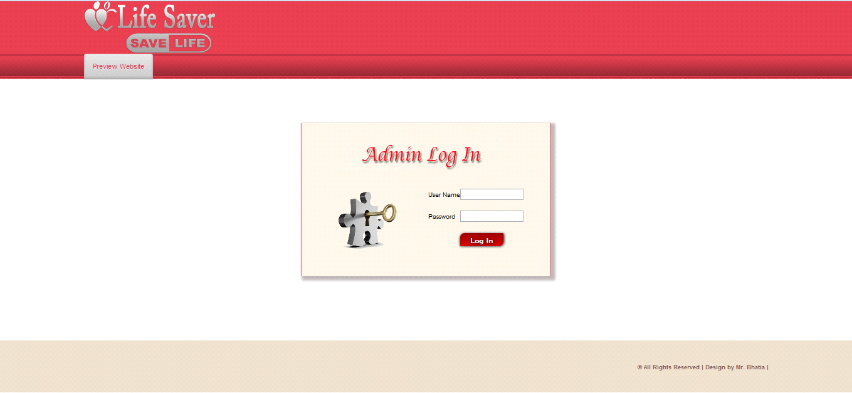

* **User**

User can register the account by fill the information about you and click on save button. He/she can add the account for the further enquiry of the blood donation. The user have to login to get more information about the blood bank.

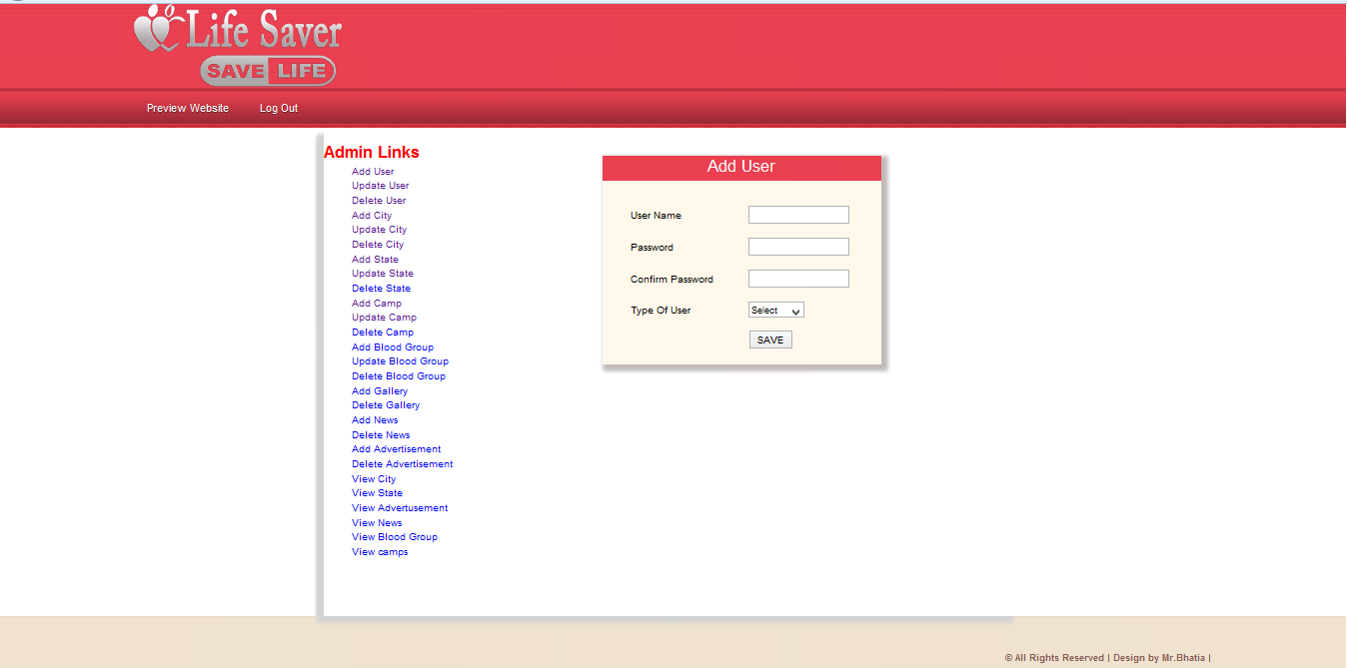

**Main Window:-** The BLOOD BANK MANAGEMENT SYSTEM is great project. this project is designed for successful completion of project on blood bank management system. the basic building aim is to provide blood donation service to the city recently. Blood Bank Management System (BBMS) is a browser based system that is designed to store, process, retrieve and analyze information concerned with the administrative and inventory management within a blood bank.

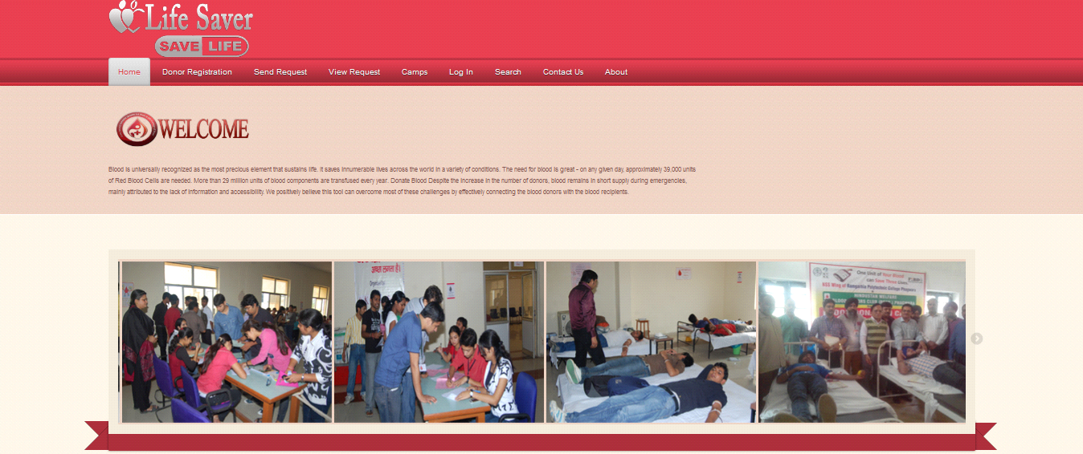

**Registration Page:** Registration page includes the information of the donor who want to register. Donor can register the account by clicking on new register. He/she can add the account for the further enquiry of the blood donation.

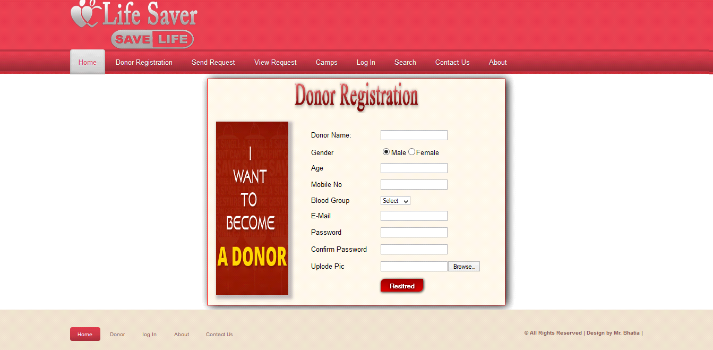

**Donor login:-** The page require donor id and password to open the donor pannel. Login is a process by which individual access to a computer system is controlled by identifying and authenticating the user through the cardinalities presented by the user. Donor can change password, update profiile or view donations etc.

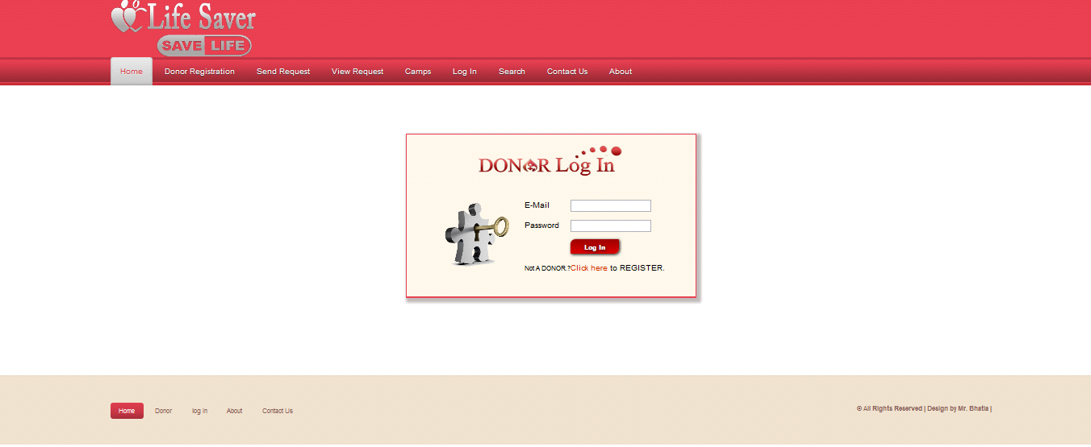

* **Complete DFD & E-R Diagrams**

Unnecessary attributes should not be introduced.Entities should be merged with common attributes.A complex entity should be simplified by decomposing a complex attribute into sub attributes.We should generalize or specialize wherever possible and appropriate. Generalization is the result of taking the union of several lower entity sets to produce higher- level entity set.

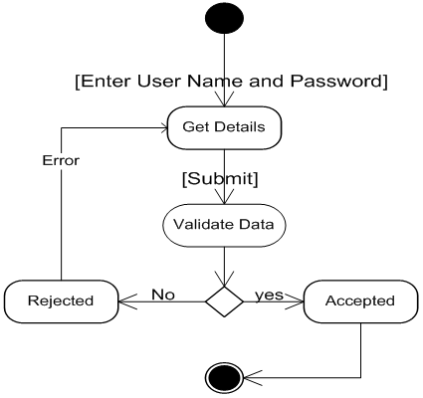

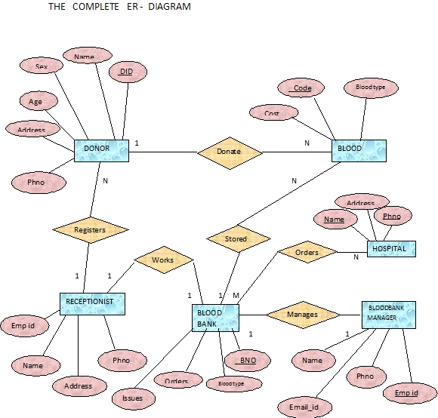

* **Data flow diagram**

**INTRODUCTION OF DFD:-**

A DFD, in simple words, is a hierarchical graphical model of a system that shows the different processing activities or functions that the system performs and the data interchange among these functions. In the DFD terminology, it is useful to consider each function as a process that consumes some input data and produces some output data.

The DFD (also known as the bubble chart) is a simple graphical formalism that can be used to represent a system in terms of the input data to the system, various processing carried out on these data, and the output data generated by the system) The main reason why the DFD technique is so popular is probably because of the fact that DFD is a very simple formalism- it is simple to understand and use. A DFD model uses a very limited number of primitive symbols to represent the functions performed by a system and the data flow among these functions.

**6.1 DFD FOR ADMIN LOGIN**

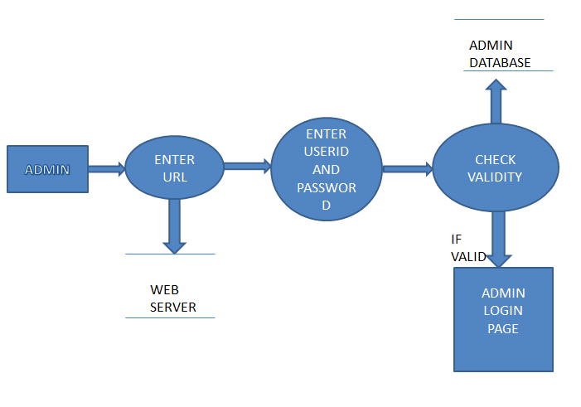

**6.2 DFD FOR USER LOGIN**

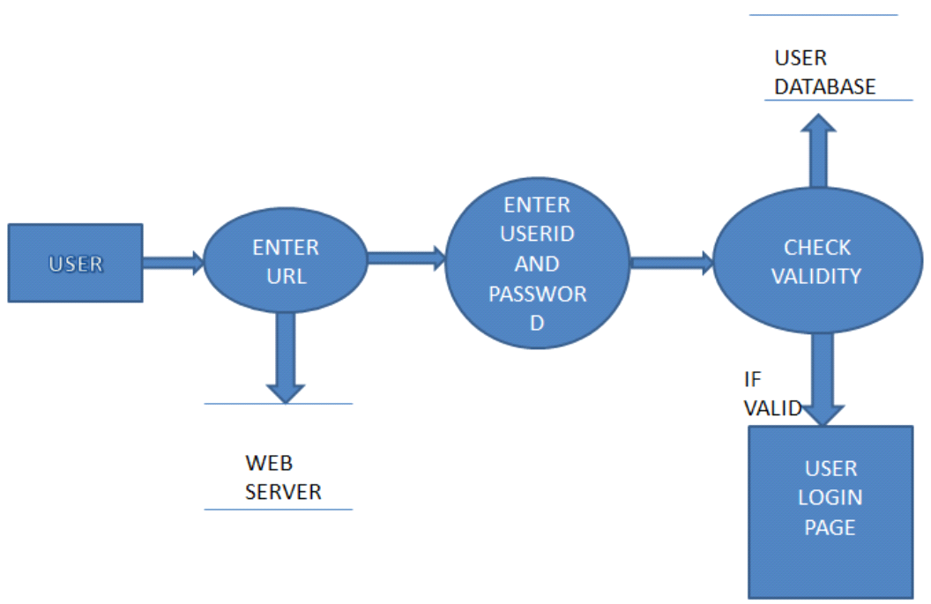

**6.3 DFD FOR ACCOUNT CREATION**

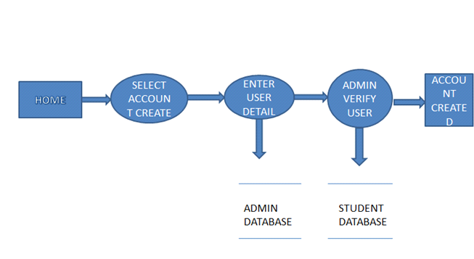

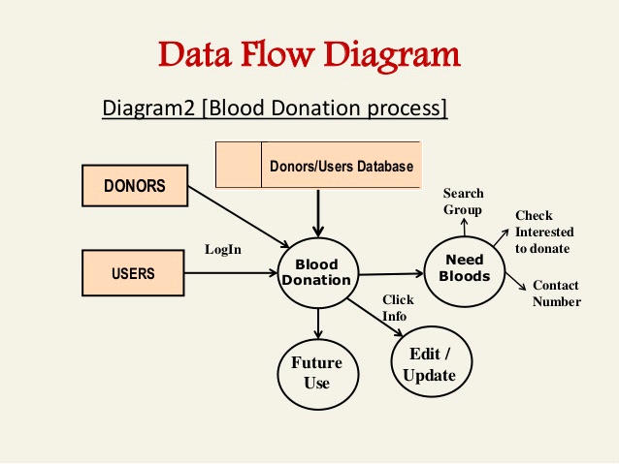

* **.Complete Snapshots**

**7.1 Home page:-** This is the home page or the main page of a blood bank management system. This is the main page of a client side. This page define all about related to project. This page also includes the galary of the camps.

Blood Donor

Equipments

Stick

Blood Recipient

Blood collection

Camp

Stock details

blood bank system project Reports

Blood issued

Blood bank system project



**Figure 7.1:Home Page of life saver**

**7.2 Registration**

Registration page includes the information of the donor who want to register. Donor can register the account by clicking on new register. He/she can add the account for the further enquiry of the blood donation.



**Figure 7.2:Registration page of Life Saver**

**7.3 Request For Blood**

Request for blood page includes the information of the donor who want to register. Donor can register the account by clicking on new register. He/she can send requests for the further enquiry of the blood donation.

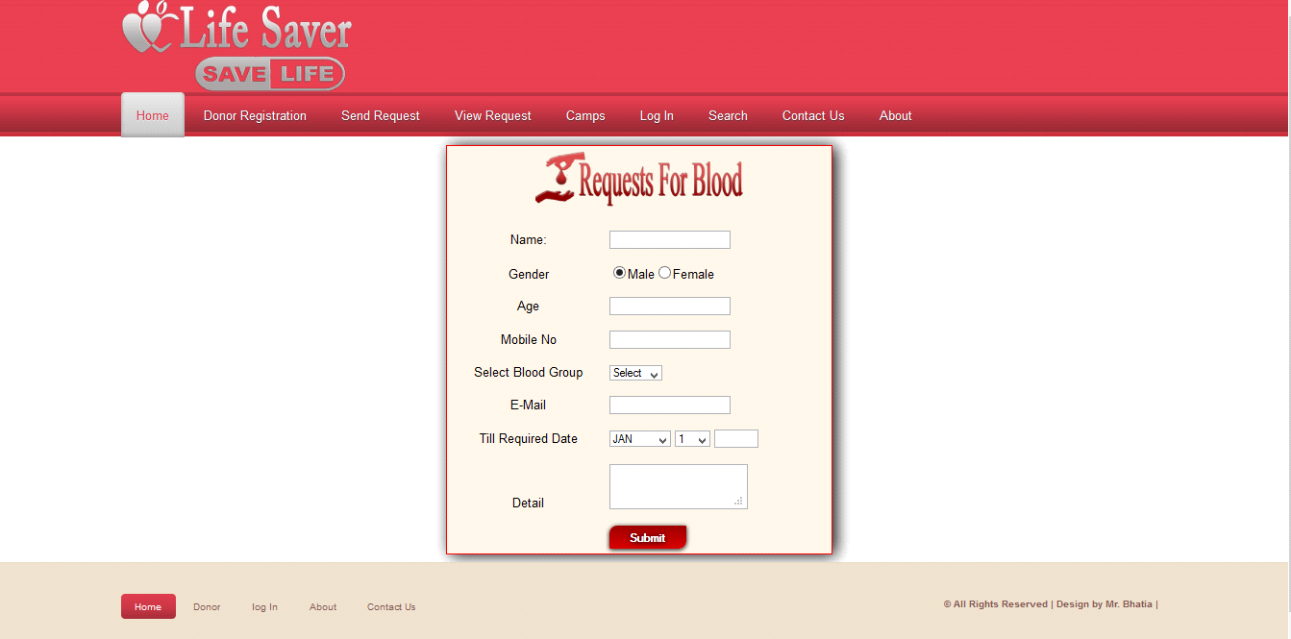

**Figure 7.3:Request for Blood page**

**7.4 Camps**

Camp page includes the information about camps, this camps organised the blood donation camp. Donor can register the account by clicking on new register.

Request for blood page includes the information of the donor who want to register. Donor can register the account by clicking on new register. He/she can send requests for the further enquiry of the blood donation.

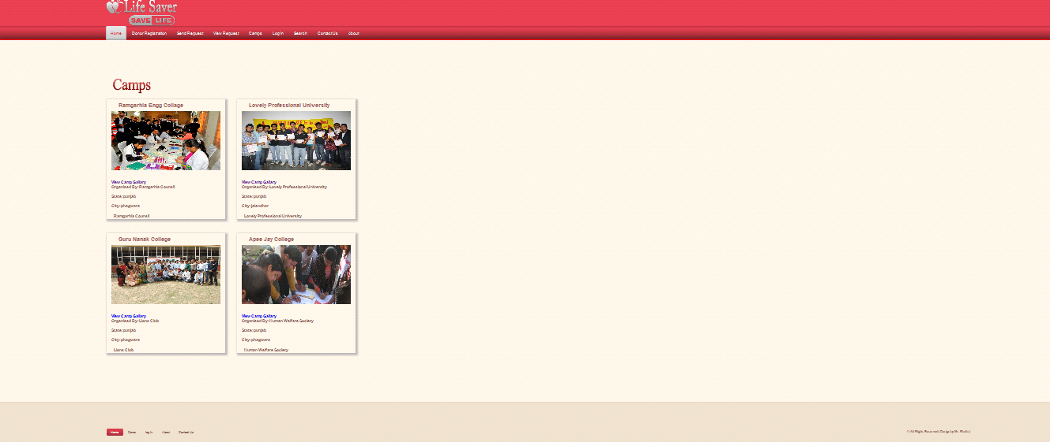

**Figure 7.4:Camps of Blood group**

**7.5 Donor Login**

It is  login menu, I have set a default E-mail and password for it. This mail id and password are store in a binary file inside this project. For Password security I have replace the password's alpha numeric character to special symbol, Dollar ($) symbol.

If you will enter the correct mail id and password, It will allow you to move to next menu otherwise it will show you error message and ask you to invalid mail id and password.

Request for blood page includes the information of the donor who want to register. Donor can register the account by clicking on new register. He/she can send requests for the further enquiry of the blood donation.

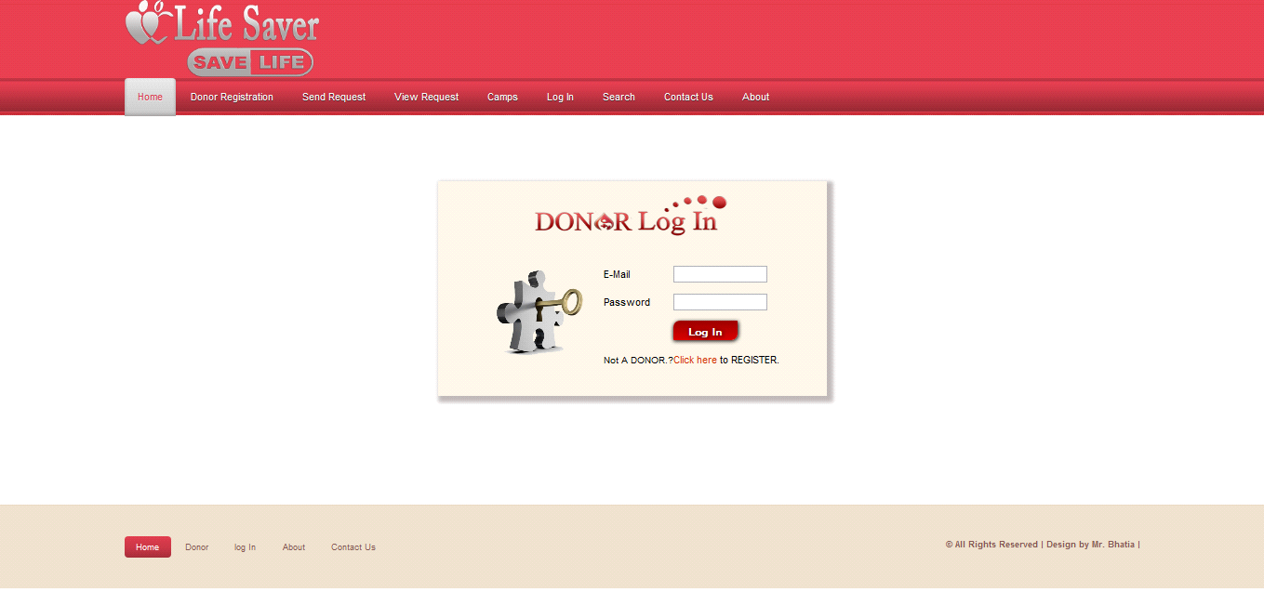

**Figure 7.5:DONOR Log In**

**7.6 Search**

Search button is used for search the donations of blood for a different defferent blood groups.

Blood groups name

* **A**
* **A+**
* **B**
* **B+**
* **AB+**
* **AB_**
* **O+**
* **O-**

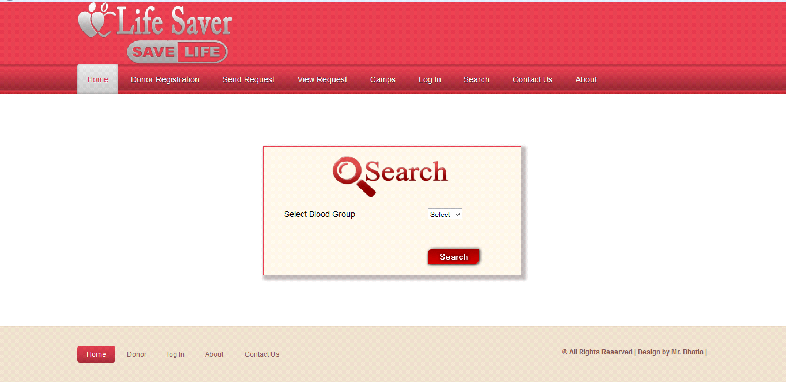

**Figure 7.6:Search for Blood**

**7.7 Contact**

In contact page any one who wants to need a blood or gaining a information about this system then he/she can contact with us.

Person will get the blood immediately he/she requested for the particular blood group he/she

Has requested.

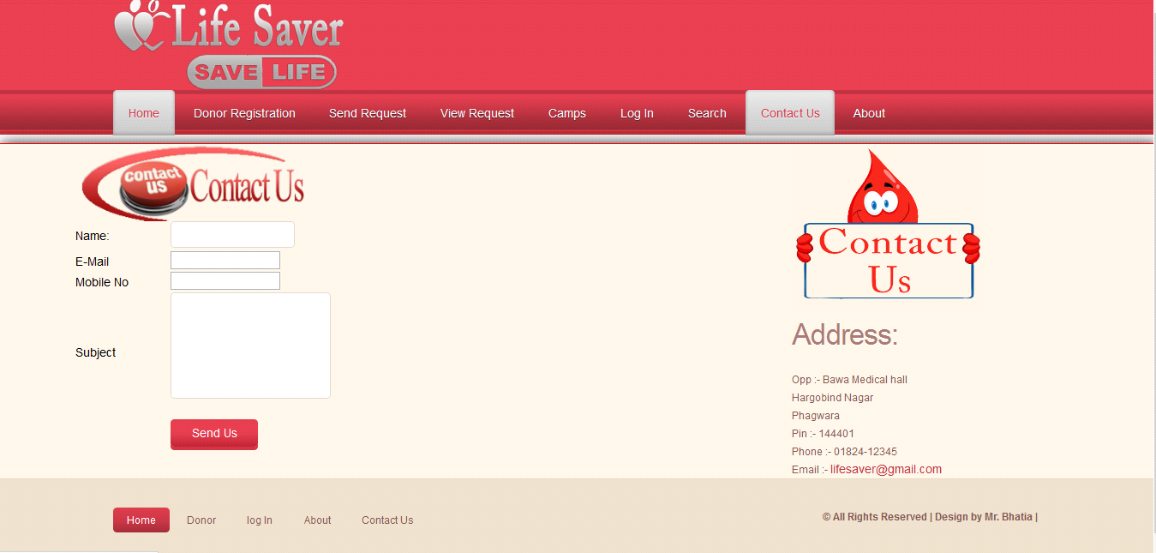

**Figure 7.7:Contact Us**

**7.8 Donor Pannel**

This page is the the welcome page of the donor panel. In this page include all the module related to Donor like :

Change password

Update profile

Blood donated

View donation

View requested

Logout

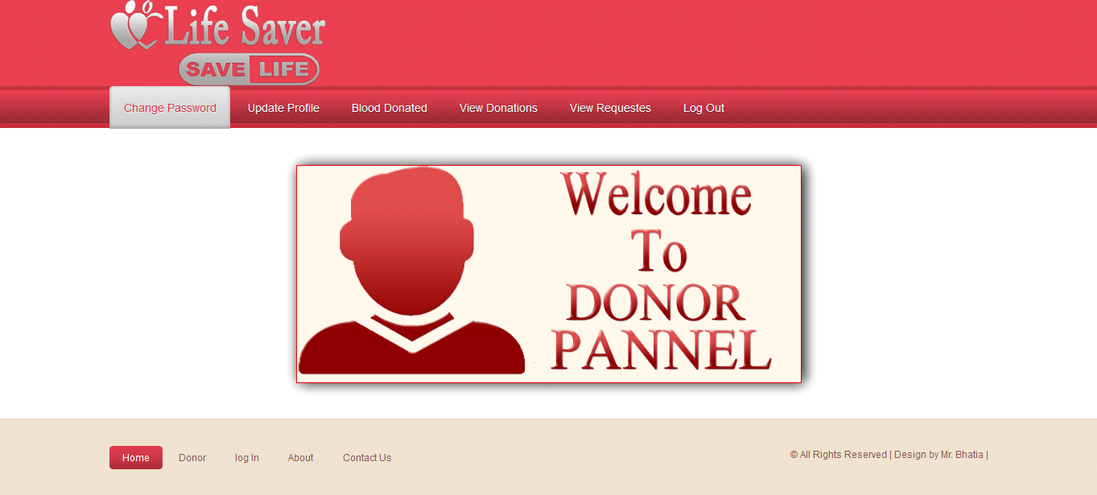

**Figure 7.8:Welcome To Donor Pannel**

**7.9 Change Password**

Above snap short describe how the donor change our password .This is only used by a donor.

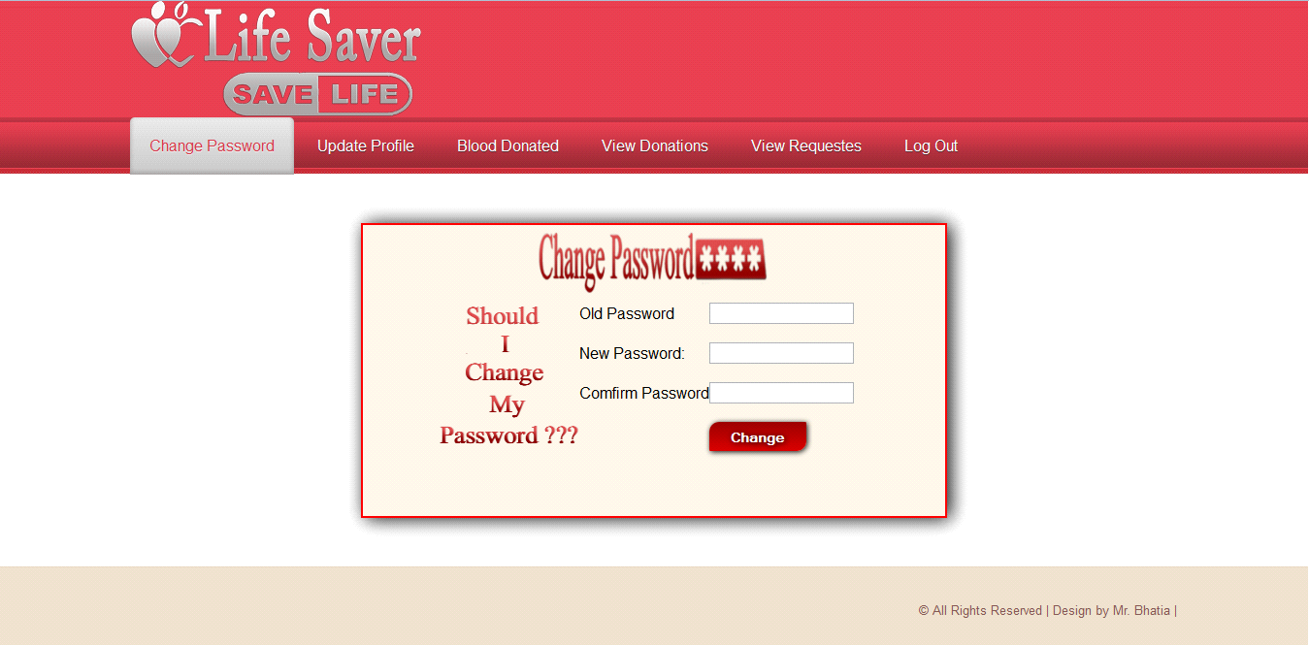

**Figure 7.9:Change Password**

**7.10 Update Profile**

Above snap short describe how the donor update our profile .This is only used by a donor.

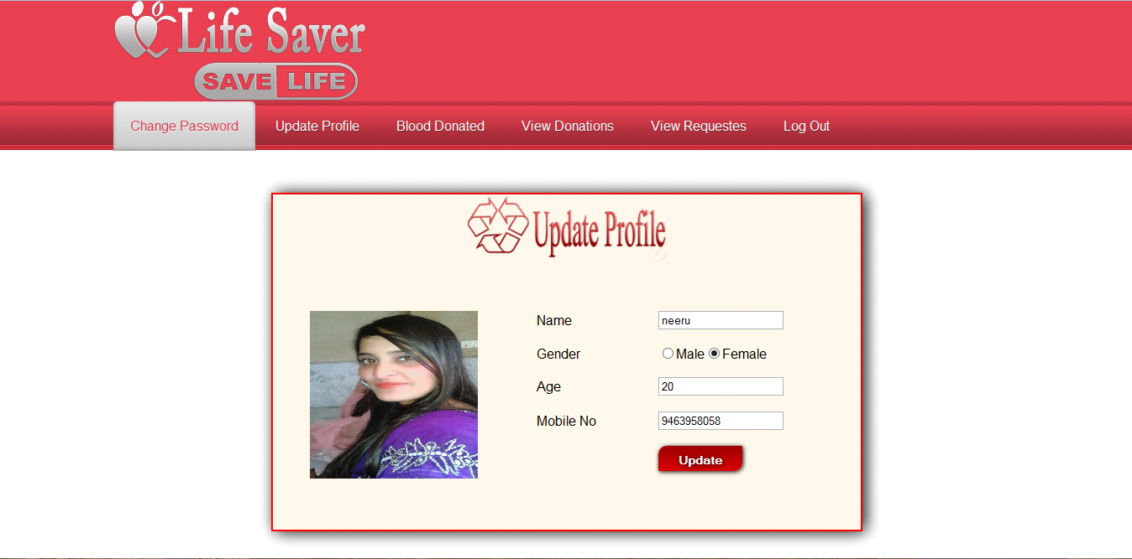

**Figure 7.10:update Profile**

**7.11 Blood Donated**

Above snap short describe about donation from donor.This is only used by a donor.

Person will get the blood immediately he/she requested for the particular blood group he/she

has requested.

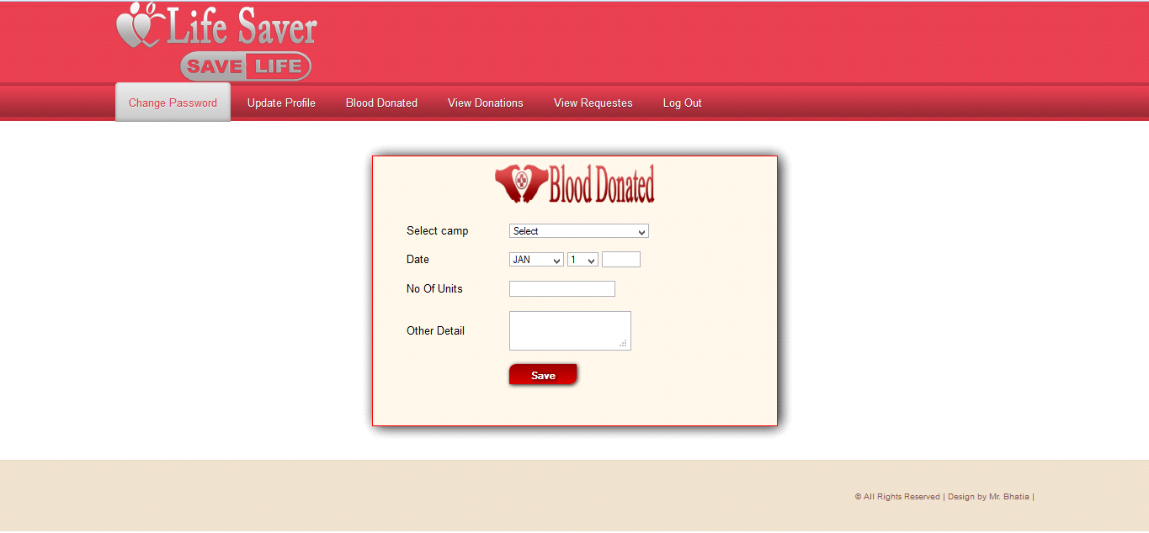

**Figure 7.11:Blood Donated**

**7.12 Admin Pannel**

This is the admin side of the project, shows all the admin page like addition , updation, deletion of the user, city,state,camps etc.

Person will get the blood immediately he/she requested for the particular blood group he/she

has requested.

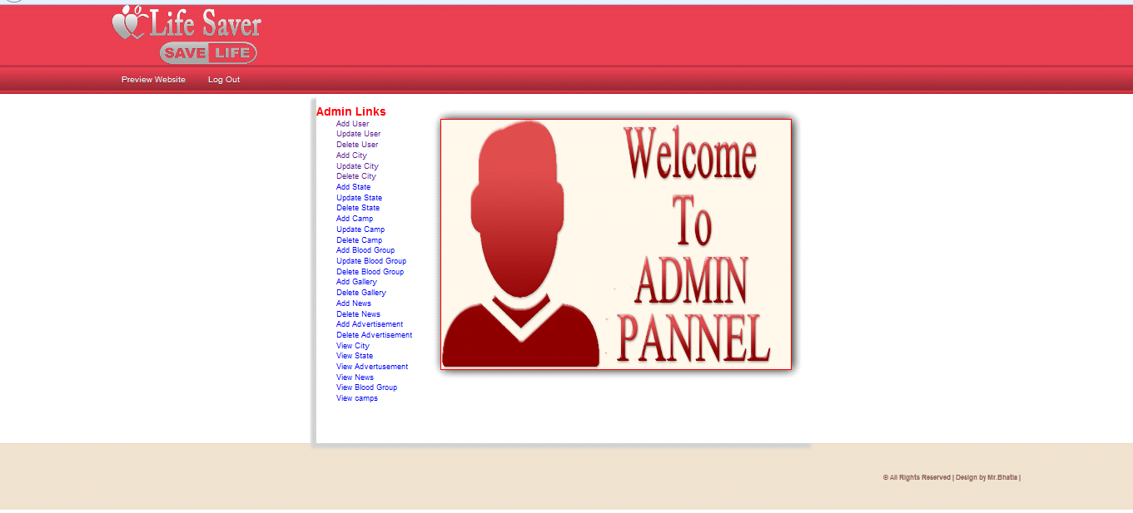

**Figure 7.12:Admin Pannel**

**7.13 Add user**

Show the addition of user.

Person will get the blood immediately he/she requested for the particular blood group he/she

has requested.

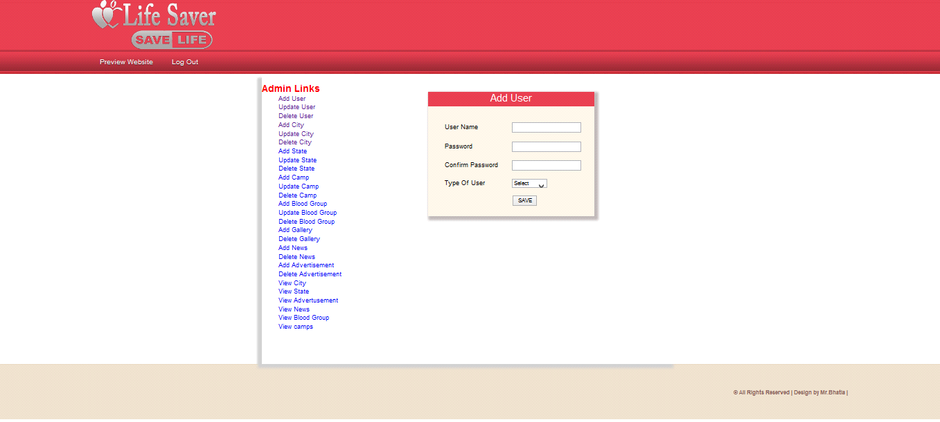

**Figure 7.13:Admin Pannel**

**7.14 Update User**

Show the updation of user.

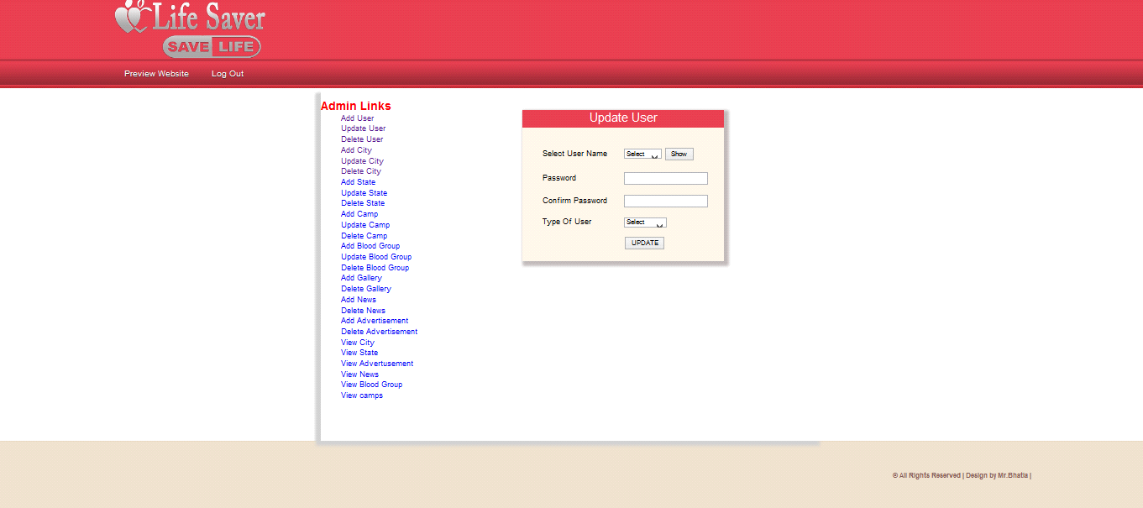

**Figure 7.14:Update User**

**7.15 Add City**

Show the addition of city.

Person will get the blood immediately he/she requested for the particular blood group he/she

has requested.

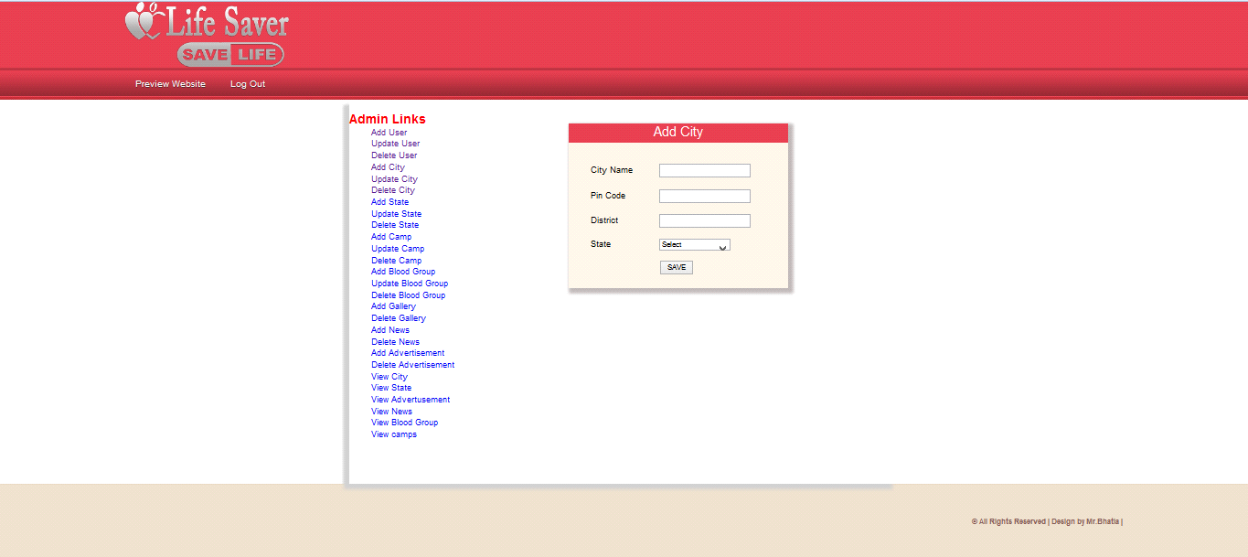

**Figure 7.15:Add City**

**7.16 Update City**

Show the updation of city.Person will get the blood immediately he/she requested for the particular blood group he/shehas requested.

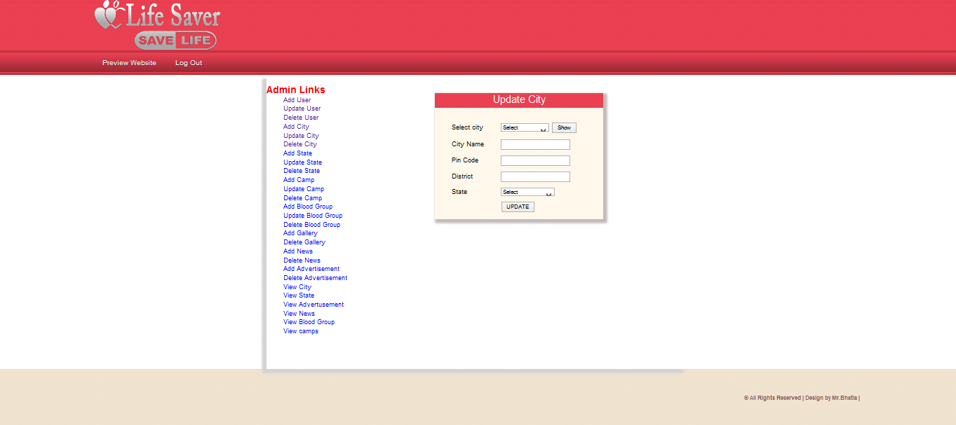

**Figure 7.16:Update City**

**7.17Add Camp**

Show the addition of camp.Person will get the blood immediately he/she requested for the particular blood group he/shehas requested.

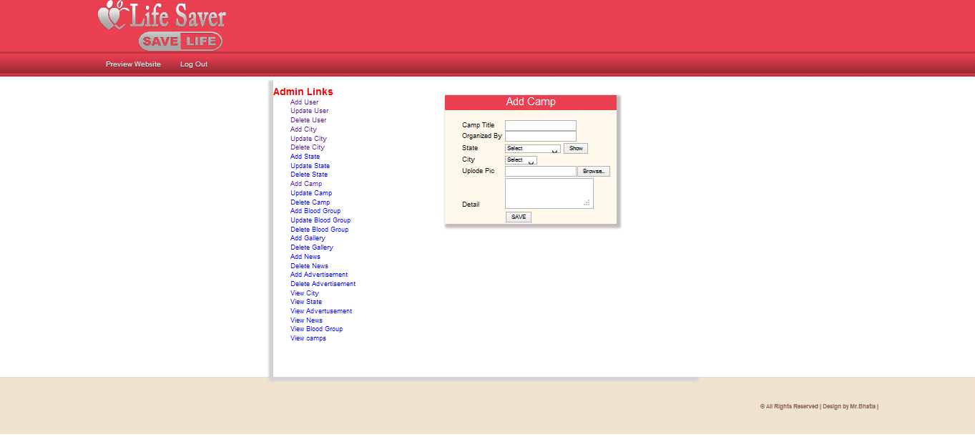

**Figure 7.17:Add Camp**

**7.18 Update Camp**

Show the updation of camp.Person will get the blood immediately he/she requested for the particular blood group he/shehas requested.

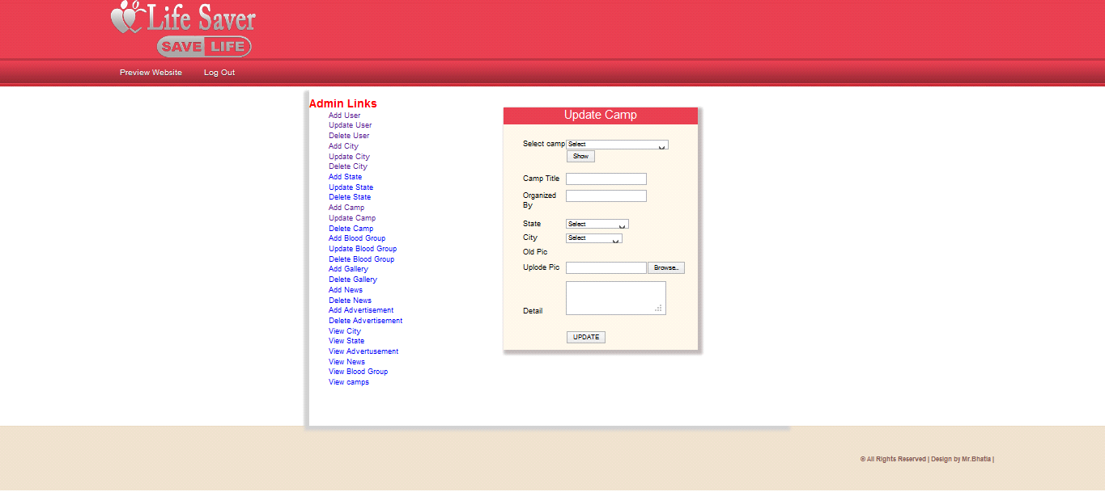

**Figure 7.18:Update Camp**

**7.19 Add State**

Show the addition of state.Person will get the blood immediately he/she requested for the particular blood group he/shehas requested.

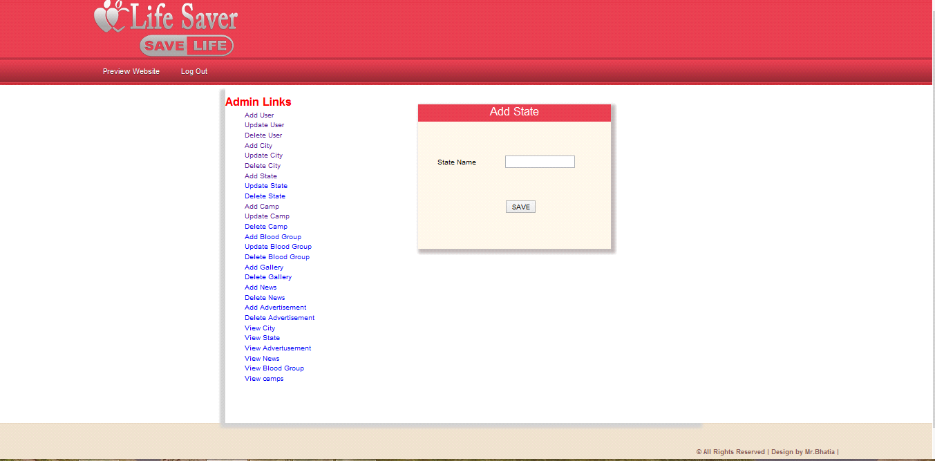

**Figure 7.19:Add State**

**7.20 Update State**

Show the updation of state. Person will get the blood immediately he/she requested for the particular blood group he/shehas requested.

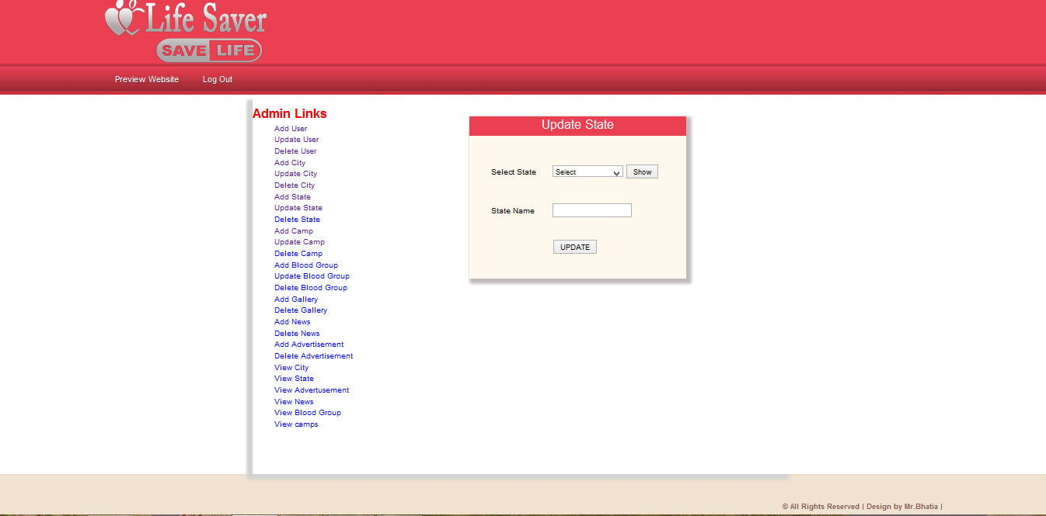

**Figure 7.20:Update State**

**7.21 View Blood Group**

This snapshort shows all the blood group. This shows blood group name and id**.** Person will get the blood immediately he/she requested for the particular blood group he/shehas requested.

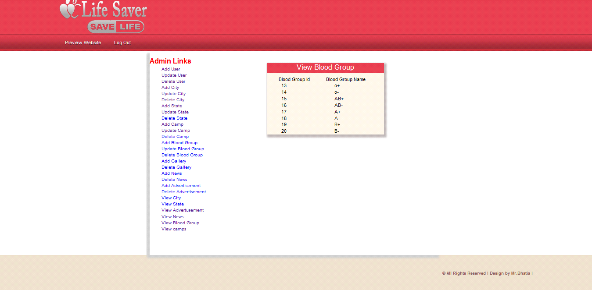

**Figure 7.21:View Blood Group**

* **Blood Donor:**

|  |  |  |  |  |
| --- | --- | --- | --- | --- |
| **Field name** | **Data** **Type** | **Constraints** | **Size** | **Description** |
| Donor_id | Int | Primary key | 30 | Donor id |
| Donor_name | Varchar | Not null | 20 | Name of Donor |
| Donor_email | Varchar | Not null | 20 | Email id of donor |
| PhoneNo | numeric | Not null | 10 | Phone number  Donor gender |
| Gender | Varchar | Not null | 20 | Age of donor  Blood group of donor |
| Age | Int | Primary key | 11 | Address of donor |
| Blood group | Varchar | Not null | 20 | Message |
| Address | Varchar | Not null | 255 | Date of posting |
| Message | Varchar | Not null | 100 |  |
| Posting date | Timestamp | Current time |  |  |
| Status | Int | Foreign key | 1 |  |

Table Name: Blood Donor

Description: - This Table is store contact information.

* **Summary and Conclusion**

With the theoretical inclination of our syllabus it becomes very essential to take the atmost advantage of any opportunity of gaining practical experience that comes along. The building blocks of this Major Project ”BLOOD BANK Management System” was one of these opportunities. It gave us the requisite practical knowledge to supplement the already taught theoretical concepts thus making us more competent as a computer engineer. The project from a personal point of view also helped us in understanding the following aspects of project development:

* The planning that goes into implementing a project.
* The importance of proper planning and an organized methodology.
* The key element of team spirit and co-ordination in a successful project.

The project also provided us the opportunity of interacting with our teachers and to gain from their best experience

* **Future Recommendation**

**BLOOD BANK** MANAGEMENT is a software application to built such a way that it should suits for all type of blood banks in **future**.

One important future scope is availability of location based blood bank details and extraction of location based donor’s detail, which is very helpful to the acceptant people. All the time the network facilities cannot be use. This time donor request does not reach in proper time, this can be avoid through adding some message sending procedure this will help to find proper blood donor in time. This will provide availability of blood in time.

* **Future Enhancement:**
* The System has adequate scope for modification in future if it is necessary.
* As there was a little number of contact person’s information given, some people may face difficulty in getting blood fast. So we like to gather more information regarding the contact persons in other cities as well as villages and will provide much more services for the people and help everyone with humanity.
* Create a Chat box to directly connect blood seekers with blood donors.
* **. Bibliography and References:**
* Googleforproblemsolving
* Wikipedia.com
* Phptpoint.com

Referring online manual from website

[www.php.net](http://www.php.net)

[www.tutorialpoints.com](http://www.tutorialpoints.com)

[www.w3school.com](http://www.w3school.com)